Other i2c documentation

Signal graph

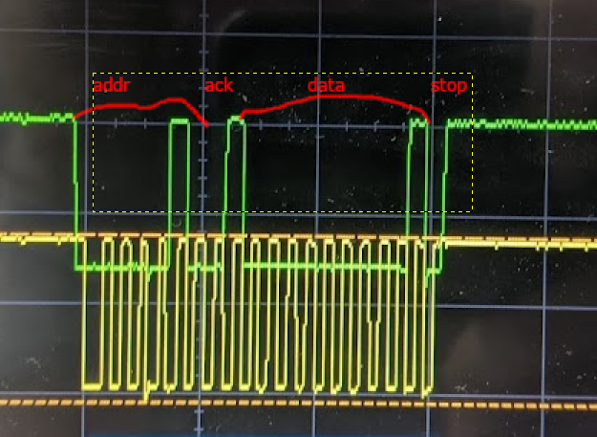

1. I2c has standard mode for 100kb, fast mode for 400kB, fast mode plus for 1mB, and high speed mode for 3.4mB
2. 3.4mB/sec, at least with standard I2C. Using this fast of a data rate may create complications with Arduino since it only has an 8MHz clock
3. Wire.setClock
4. 32